# CS 255 System Design Document Template Reese Thurman

## UML Diagrams

### UML Use Case Diagram

### UML Activity Diagrams

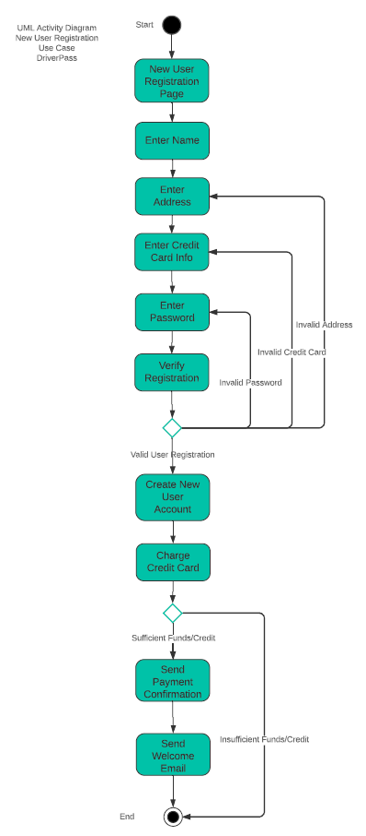

### UML Sequence Diagram

### UML Class Diagram

## Technical Requirements

DriverPass will need to be structured as a web-based cloud application, compatible for both desktop and mobile platforms in order to meet all user requirements. Users will require access to online practice tests and the online scheduling system to complete exams and in-person instruction. Additionally, the owner of DriverPass needs to access analytic data both online and offline. Accordingly, the system will need to operate in both online and offline environments using cloud technology.

DriverPass should be fast enough to accommodate customer growth over time. It should offer a minimum response time of 2-3 seconds with minimal lag time. Otherwise, students may become frustrated and stop taking online practice tests or give up on scheduling in-person lessons. Therefore, the system should be capable of processing at least 10,000 requests per second. This is the optimal speed for fast response times, minimal latency, and scalability to accommodate thousands of online students.

Given the fact that this system will be a web-based platform with sufficient scalability to accommodate many online students, Microsoft Azure would be an ideal choice. Azure offers web hosting and cloud services consistent with DriverPass’ requirements. The back end will require a database to support the application, such as MYSQL. The database will be used to store customer information, including first name, last name, address, phone number, state, and their credit card number, expiration date, and security code. The database will also store user categories, such as student, instructor, and administrator.